Kamran Gul
CMS: 023-25-0161
CS AI (C)
Lab # 4

Task 1:
Write a program in C++ language that asks user to enter two numbers, a and b; and tells the user whether a is divisible by b or not?
Solution:
#include<iostream>
using namespace std;
int main(){
int number1,number2;
cout<<"Enter value of A: ";
cin>>number1;
cout<<"Enter value of B: ";
cin>>number2;

if(number1 % number2 == 0)
cout<<number1<<" is divisible by "<<number2;
else
cout<<number1<<" is not divisible by "<<number2;

cout<<endl;
system("PAUSE");
return 0;
}
Output:
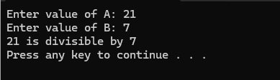

Task 2:
Write a program in C++ language that asks user to enter a character, x; and verifies whether it’s a number, vowel or a consonant? You know it very well, a character in computer science holds an entity but not more than one alphabet, or number or special symbol.
Solution:
#include<iostream>
using namespace std;
int main(){
char ch;
cout<<"Enter a character to check: ";
cin>>ch;

if (ch=='0' || ch =='1' || ch =='2' || ch =='3' || ch =='4' || ch =='5'
|| ch =='6' || ch =='7' || ch =='8' || ch =='9')
cout<<"it is a number";
else if( ch =='a' || ch =='e' || ch =='i' || ch =='o' || ch =='u')
cout<<"it is a vowel";
else
cout<<"it is a consonent";

cout<<endl;
system("PAUSE");
return 0;
}
Output:
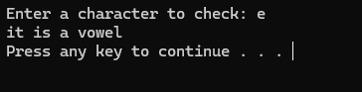

Task 3:
A number can be an even or can be odd. It is either positive or negative. Or in all other case it can be nothing, but a zero. Well, what if we combine them all. Write a program that asks user to enter a number. Your program, then, tells that the number entered is one of these: positive even, positive odd, negative even, negative odd or it’s nothing but a zero.
Solution:
#include<iostream>
using namespace std;
int main(){
int num;
cout<<"Enter Number: ";
cin>>num;
if(num==0)
cout<<"The number is zero";
else if(num > 0)
if(num % 2 == 0)
cout<<"The number is POSITIVE and EVEN";
else
cout<<"The number is POSITIVE and ODD";
else if( num < 0)
if(num % 2 == 0)
cout<<"The number is NEGATIVE and EVEN";
else
cout<<"The number is NEGATIVE and ODD";

cout<<endl;
system("PAUSE");
return 0;
}
Output:
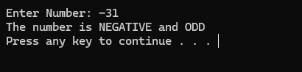

Task 4:
At Icon by Ghouri’s Store, on purchasing above a certain amount, the customer gets a discount of 10% on total bill. It is meant when the amount of all purchased items is more than Rs. 5,000. If quantity and price per item are input through the keyboard, then decide whether the customer is able to get discount or not?
Solution:
#include<iostream>
using namespace std;
int main(){
int quantity,price,total;
cout<<"Enter Quantity of item: ";
cin>>quantity;
cout<<"Enter price of item: ";
cin>>price;

total = quantity * price;

if (total> 5000){
total -= total / 10;
cout<<"Your Total Bill is: "<<total;
}
else
cout<<"Your Total Bill is: "<<total;

cout<<endl;
system("PAUSE");
return 0;
}
Output:
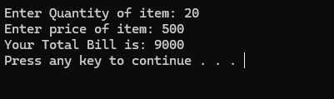

Task 5:
In K-Electric the gross salary of an employee is calculated as: (a) If the basic salary of an employee is below Rs. 15,000; then Rental Allowance = 30% of basic salary and Dining Allowance = 15% of basic salary. (b) If his salary is in between Rs. 15,000–20,000 then Rental Allowance = Rs. 6,000 and Dining Allowance = 20% of basic salary. Write a program such that, if the employee’s basic salary is input through the keyboard write a program to find his Gross Salary.
GrossSalary = BasicSalary +RentalAllowance +DiningAllowance
Solution:
#include<iostream>
using namespace std;
int main(){
float grossSalary,basicSalary,rentalAllowance,dinningAllowance;
cout<<"Enter your Basic Salary: ";
cin>>basicSalary;

if(basicSalary < 15000){
rentalAllowance = (30.0/100) * basicSalary;
dinningAllowance = (15.0/100) * basicSalary;
grossSalary = basicSalary + rentalAllowance + dinningAllowance;
cout<<"\n\tYour Gross Salary is: "<<grossSalary;
}
else if(basicSalary > 15000 && basicSalary < 20000){
rentalAllowance = 6000;
dinningAllowance = (20.0/100) * basicSalary;
grossSalary = basicSalary + rentalAllowance + dinningAllowance;
cout<<"\n\tYour Gross Salary is: "<<grossSalary;
}

cout<<endl;
cout<<endl;
system("PAUSE");
return 0;
}
Output:
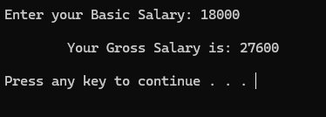

Task 6:
If cost price and selling price of an item is input through the keyboard, write a program to that tells seller is at profit or loss? Further, it should ask user to enter ‘C’ if he or she wants to know how much profit or loss seller incurred.
Solution:
#include<iostream>
using namespace std;
int main(){
char ch;
int costPrice,sellingPrice;
cout<<"Enter Cost Price: ";
cin>>costPrice;
cout<<"Enter Selling Price: ";
cin>>sellingPrice;

if ( costPrice > sellingPrice){
cout<<"Your are at loss"<<endl;
cout<<"Do you want to know how much is the loss?? ";
cout<<"Press \'c\' to check... ";
cin>>ch;
if (ch == 'c' || ch == 'C')
cout<<"Your Total loss is: "<< costPrice - sellingPrice;
}
else{
cout<<"Your are at Profit"<<endl;
cout<<"Do you want to know how much is the profit?? ";
cout<<"Press \'c\' to check... ";
cin>>ch;
if (ch == 'c' || ch == 'C')
cout<<"Your Total profit is: "<< sellingPrice - costPrice;
}
cout<<endl;
system("PAUSE");
return 0;
}
Output:
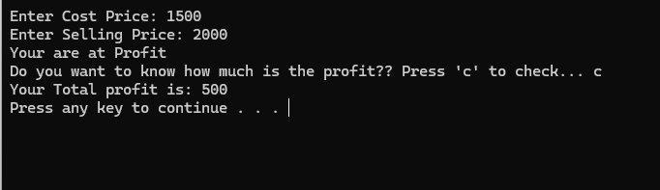
Task 7:
If the ages of Mubashir, Parkash and Sooraj are taken as input from user, write a program that tell who is the youngest of them.
Solution:
#include<iostream>
using namespace std;
int main(){
int a,b,c;
cout<<"Enter age of Mubashir: ";
cin>>a;
cout<<"Enter age of Parkash: ";
cin>>b;
cout<<"Enter age of Sooraj: ";
cin>>c;

if (a<b && a<c )
cout<<"Mubashir is the Youngest...";
else if (b<a && b<c )
cout<<"Parkash is the Youngest...";
else
cout<<"Sooraj is Youngest...";

cout<<endl;
system("PAUSE");
return 0;
}
Output:
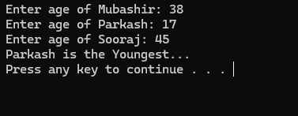

Task 8:
Cabinets and Boxes are objects that are mostly in cubic shape. Make a program that takes inputs like height, width and depth from user and then calculate volume of the cube: volume = height width depth
Solution:
#include<iostream>
using namespace std;
int main(){
int a,b,c,volume;
cout<<"Enter Height: ";
cin>>a;
cout<<"Enter Depth: ";
cin>>b;
cout<<"Enter width: ";
cin>>c;

volume = a * b * c;

if (volume <= 10)
cout<<"Extra Small";
else if (volume <= 25)
cout<<"Small";
else if (volume <= 75)
cout<<"Medium";
else if (volume <= 100)
cout<<"Large";
else if (volume <= 250)
cout<<"Extra Large";
else
cout<<"Extra Extra Large";

cout<<endl;
system("PAUSE");
return 0;
}
Output:
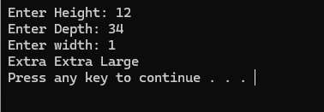

Task 9:
team nascent innovations is a software house that insures the software developers working with them in the following cases: a) If the software developer is married. b) If the software developer is unmarried, male and above 28 years of age. c) If the software developer is unmarried, female and above 22 years of age. In all other cases, the software developer is not insured. If marital status, gender and age of the software developer are user-defined, write a program to determine whether the software developer is to be insured or not.
Solution:
#include<iostream>
using namespace std;
int main(){
int age;
char status,gender;

cout<<"Enter your Gender (m/f): ";
cin>>gender;
cout<<"Enter your marital status (y/n): ";
cin>>status;
cout<<"Enter your age: ";
cin>>age;

if ( status == 'y')
cout<<"Congrats! \n You are Eligible"<<endl;
else if( status == 'n' && gender == 'm' && age > 28)
cout<<"Congrats! \n You are Eligible"<<endl;
else if( status == 'n' && gender =='f' && age > 22)
cout<<"Congrats! \n You are Eligible"<<endl;
else
cout<<"Sorry! \n You are Not Eligible...";

cout<<endl;
system("PAUSE");
return 0;
}
Output:
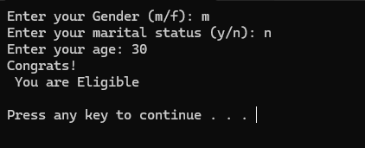
Task 10:
Suppose you are an information officer in the admission department at Sukkur IBA Univer sity. Numbers of people come to you with several questions regarding admission. Officers in the admission department came up with a certain criteria as follows: a) For admission in Department of Computer Science 50% score required in student’s high school examination but student must has background of engineering. b) For admission in Department of Software Engineering 55% score required in high school and background should be of engineering or medical. c) For Business Management minimum 45% score is required no previous background is essential. Write a program to take input high school’s score, major (E for pre-eng, M for pre-medical) and output for which program(s), student is eligible to apply.
Solution:
#include<iostream>
using namespace std;
int main(){
int percentage;
char background;

cout<<"Enter your High School Percentage: ";
cin>>percentage;
cout<<"Enter your Background \n(\'e\' for Engineering and \'m\' for Medical (e/m): ";
cin>>background;
cout<<"\nYou are Eligible for: "<<endl<<endl;

if ( percentage > 50 && background == 'e' )
cout<<"Computer Science"<<endl;
if( percentage > 55 && (background == 'e' || background == 'm'))
cout<<"Software Engineering"<<endl;
if(percentage > 45)
cout<<"Buisness Management"<<endl;
else
cout<<"Sorry! \n You are Not Eligible...";
cout<<endl;
system("PAUSE");
return 0; }
Output:
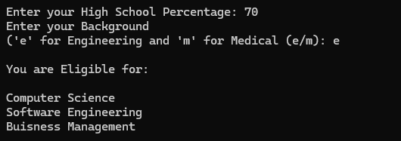
Task 11:
pakistan army has very tough criteria for recruitment. It requires an applicant to be fit on the following set of criteria. All are must. You may consider the value of Nationality as a character input. Criterion Accepted Value Nationality P or K Age 18-22 Education minimum 12 years
Solution:
#include<iostream>
using namespace std;
int main(){
char nationality;
int age,education;

cout<<"Enter your Nationality - Pakistan/Kashmir: (p/k) ";
cin>>nationality;
cout<<"Enter your age: ";
cin>>age;
cout<<"Enter your education in years: ";
cin>>education;

if (
(nationality == 'p' || nationality == 'k') &&
(age>=18 && age <=22) &&
(education >= 12)
)

cout<<"Congrats! \nYou are Eligible to Apply";
else
cout<<"Huuuh! \nYou are not eligible to apply ";

cout<<endl;
system("PAUSE");
return 0;
}
Output:
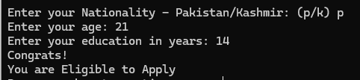

Task 12:
Sindhri is a famous restaurant in Sukkur, they have almost manual process. Now they are willing to use computers and need a computer program that helps them to process their orders. They defined their process as: When a user comes and ask about deals, we replied we have three deals for three kind of budget limits and our deals are associated with days. Often we have complementary food to our customers. You have to write a computer program using C++ language that asks user to enter the day as input, then it asks how much money you have, if it is right day and money is suitable for deal then algorithm suggest it otherwise says “Sorry! you cannot have any deal in this range, you can buy single items”. They showed following menu that bears information.
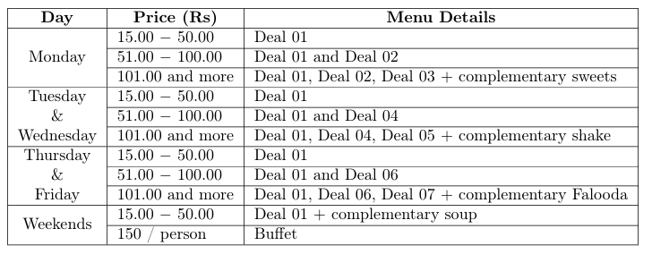
Solution:
#include<iostream>
#include<string>
using namespace std;
int main(){
string day;
int money;

cout<<"Enter the name of the day: ";
cin>>day;
cout<<"How much money do you have??? ";
cin>>money;

if(money >=15){
if(day=="monday"){
if(money <= 50)
cout<<"Deal 1";
else if(money <= 100)
cout<<"Deal 1 | Deal 2";
else if(money > 100)
cout<<"Deal 1 | Deal 2 | Deal 3 | Complementary Sweets ";
}

else if((day=="tuesday") || (day =="wednesday")){
if(money <= 50)
cout<<"Deal 1";
else if( money <= 100)
cout<<"Deal 1 | Deal 4";
else if(money > 100)
cout<<"Deal 1 | Deal 4 | Deal 5 | Complementary Shake ";
}

else if(day=="thursday" || day =="friday"){
if(money <= 50)
cout<<"Deal 1";
else if(money <= 100)
cout<<"Deal 1 | Deal 6";
else if(money > 100)
cout<<"Deal 1 | Deal 6 | Deal 7 | Complementary Falooda ";
}

else if(day=="saturday" || day =="sunday"){
if(money <= 50)
cout<<"Deal 1 | Complementary Soup";
else if( money >= 150)
cout<<"One person Buffet";
else
cout<<"You cant have any deal, buy separately! ";
}

else
cout<<"Wrong Entry!!!";
}
else
cout<<"You cant have any deal, buy separately! ";

cout<<endl;
system("PAUSE");
return 0;
}
Output:
